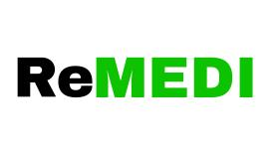
MSME HACKATHON 5.0

Proposal:

1. Title of the Project:

ReMEDI – A Smart Donation & Recycling Platform for Medicines

2. Description of the Project:

ReMEDI is a smart app that lets people donate unused or expired medicines. Based on expiry, medicines are given to NGOs or sent to research and fertilizer centers. On donation, users get discount coupons for future purchases which is applicable only at Remedi. This encourages donations(which people are not usually interested), reduces medicine waste, and promotes affordable healthcare. With both online and offline access, Remedi creates a complete cycle of reuse, support, and sustainability — all in one platform including fast delivery. There is a special feature in the app where people can get monthly packages of medicine with the remainder.

Statement of the Problem:

Many people throw away unused or expired medicines. This harms the environment and is a waste of resources. At the same time, many people can’t afford to buy costly medicines. There is no proper platform to donate, recycle, or reuse medicines safely.

Introduction:

ReMEDI is developed with the goal of reducing medicine waste and creating a useful cycle. It connects donors, recipients, and industries under one platform. It works both online and offline, so it can reach more people. Users are encouraged through discounts and packages.
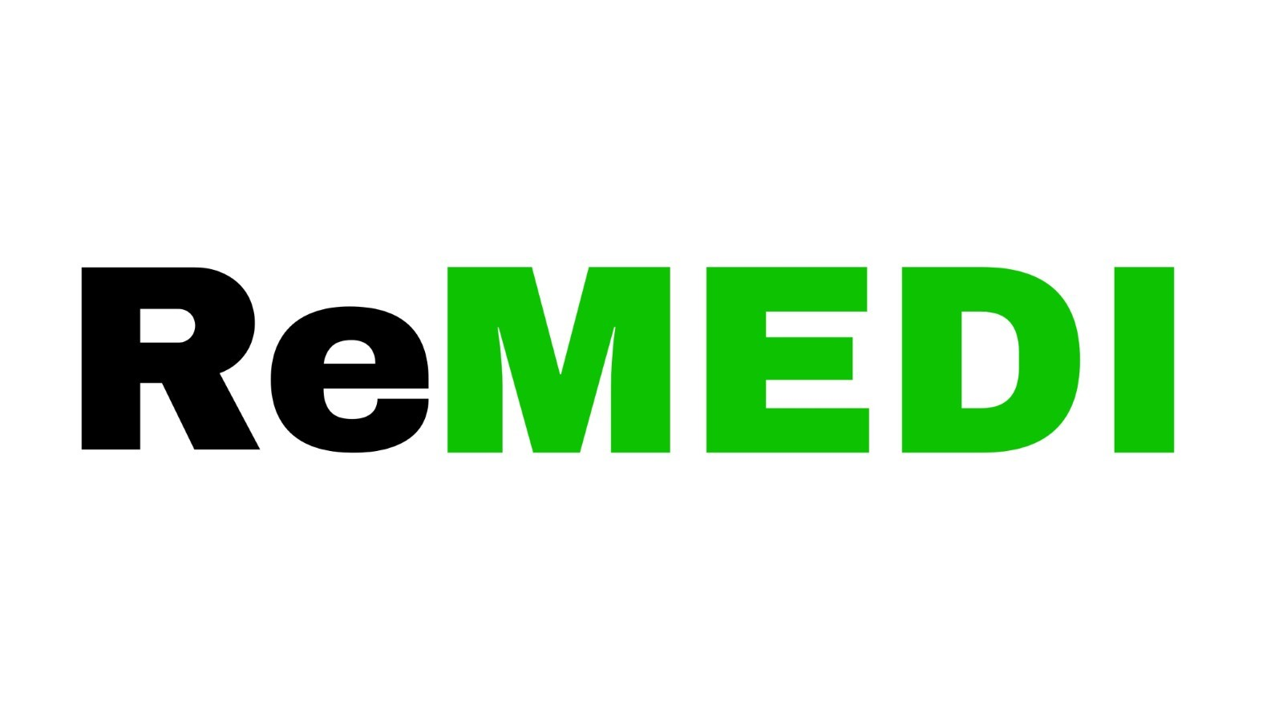

Objective:

- Reduce medicine waste- Provide low-cost medicines to users- Help NGOs and orphanages with donated medicines- Give expired medicines to fertilizer/research centres- Reward users with coupon cards to motivate donations
- Sustainable development

Block Diagram:
User receives coupon card on donation
User buys medicine on discount at ReMEDI
If not expired
Medicine is donated to (orphanges/NGOs)
If expired
User donates medicine via ReMEDI app
ReMEDI collects the medicine
Medicine is handled to industries (fertilizer/ research centre)*ReMEDI receives money

Product Specification:

- App with donate option
- Coupon card system
- Online & offline access
- Package subscriptions with reminders
- Local delivery system
- Price discounts and monthly offers

Operation and Performance:

Users donate medicines via the app or visit the offline store. Based on expiry, medicines are sent to NGOs or industries. Users get discount coupons. Medicines are bought at wholesale price and sold at slightly higher price with discounts applied. Expired medicines also generate money when sent to fertilizer/research labs.

Beneficial to the Society:

- Helps poor people get medicine
- Supports NGOs and orphanages
- Reduces waste and pollution
- Educates users on proper disposal
- Saves money for everyone involved

Newness / Uniqueness:

ReMEDI stands out because of its coupon reward for donation, safe reuse, and expired medicine handling. No existing platform offers all these services together. It also works offline which makes it useful for rural areas.

Market Opportunity:

The healthcare market is growing every day. Medicine waste is a big issue. People want cheap medicines and eco-friendly solutions. ReMEDI fills this gap. It can attract users, NGOs, and industries. It also creates jobs at local stores.

Marketing Plan:

- Promote on social media and medical forums
- Partner with local clinics, pharmacies, and NGOs
- Offer first-time coupons to new users
- Encourage word-of-mouth via discounts
- Reach rural areas through offline Remedi centers

Financial Plan:
For Example
- reMedi buys medicine(considering only a single medicine) at
rs 100 from the manufacturer
- Sell at Rs. 125 with Rs. 10 discount (which he received on donation)→ net Rs. 115
- Earn Rs. 115 from sales + Rs. 15 from expired medicine sent to industry(estimated)
- Total: Rs. 130 → Profit: Rs. 30
Monthly Estimation:
- 100 units/day → 3000/month
- Revenue: Rs. 390000 [ 3000*115 = 345000+45000(from industries by taking rs 15 for each product donated = 3000*15) ]
- Worker salary: Rs. 25,000*2= 50,000(initially 2 workers)
- Net profit/month: Rs. 40,000
*Also earns from downloads, ads, and industry deals later.
The above plan is based upon considering one variety of medicine by using least costs . The discounts are based upon the purchases. For example the customer gets discount only if they buy medicines valued more than 100. Higher the price of medicine greater are the discounts. The price received from the industries/research centers is based upon fixed deal.

